MANCHITRA: AI for Community Visuals
Community Project Report
Submitted by
SARTHAK RUNTHALA  (23331A4758) | R.YASWANTHI KUMARI  (23331A4755)
P.S.SAI BALAJI  (23331A4746) | K.SHIVA SANKAR  (23331A4723)
In partial fulfillment for the award of the degree
of
BACHELOR OF TECHNOLOGY
IN
COMPUTER SCIENCE & ENGINEERING
(Artificial Intelligence & Machine Learning)
Under the esteemed Guidance of

G. Gayathri
Assistant Professor



DEPARTMENT OF DATA ENGINEERING

MAHARAJ VIJAYARAM GAJAPATHI RAJ COLLEGE OF ENGINEERING (Autonomous)

(Approved by AICTE, New Delhi, and permanently affiliated to JNTUGV, Vizianagaram), Listed u/s 2(f) & 12(B) of UGC Act 1956.

Vijayaram Nagar Campus, Chintalavalasa, Vizianagaram-535005, Andhra Pradesh

October, 2025

CERTIFICATE



This is to certify that the project entitled “Project title” is the bonafide work carried out by Sarthak Ruthala(23331A4758), R.Yaswanthi Kumari(23331A4755),P.S.Sai Balaji(23331A4746), K.Shiva Sankar(23331A4723) of B.Tech V Sem CSE-ICB, M.V.G.R. College of Engineering (Autonomous), Vizianagaram, during the year 2025-2026, in partial fulfilment of the requirements for the award of the Degree of Bachelor of Technology and that the project has not formed the basis for the award previously of any degree or any other similar title.

Signature of Project Guide Signature of Head of the Department
G.Gayathri Dr.V.Jyothi
Assistant Professor Associate Professor
Dept. of Data Engineering. Dept. of Data Engineering.

DECLARATION

We hereby declare that the work done on the dissertation entitled “MANCHITRA: AI for Community Visuals” has been carried out by us and submitted in partial fulfilment for the award of credits in Bachelor of Technology in Computer Science and Engineering (Internet Of Things Cyber Security With Blockchain Technology) of M.V.G.R College of Engineering (Autonomous) and affiliated to JNTUGV, Vizianagaram. The various contents incorporated in the dissertation have not been submitted for the award of any degree of any other institution or university.

Sarthak Runthala
(23331A4758)

R. Yaswanthi Kumari
(23331A4755)

P.S.Sai Balaji
(23331A4746)

K. Shiva Sankar
(23331A4723)

ACKNOWLEDGEMENT

We express our sincere gratitude to (G.Gayathri) for his/her invaluable guidance and support as our mentor throughout the project. Her unwavering commitment to excellence and constructive feedback motivated us to achieve our project goals. We are greatly indebted to her for her exceptional guidance.
Additionally, we extend our thanks to Prof. P.S. Sitharama Raju (Director), Dr. Y.M.C. Shekar (Principal), and Dr. Jyothi (Head of the Department) for their unwavering support and assistance, which were instrumental in the successful completion of the project. We are thankful for and fortunate enough to get constant encouragement and guidance from our Project Coordinator Mrs. N. Sushma Rani.
We also acknowledge the dedicated assistance provided by all the staff members in the Department of Data Engineering. Finally, we appreciate the contributions of all those who directly or indirectly contributed to the successful execution of this endeavour.

Sarthak Runthala(23331A4758)
R. Yaswanthi Kumari(23331A4755)
P.S.Sai Balaji (23331A4746)
K.Shiva Sankar (23331A4723)

ABSTRACT

MANCHITRA: AI for Community Visuals is an AI-driven project that transforms community data into interactive visual maps and insights. It helps identify local challenges, track development, and support data-based decision-making. The project promotes transparency and community engagement through intelligent visualization tools.

TABLE OF CONTENTS
Contents | Page No.
List of Abbreviations
List of Figures
List of Tables
1. Introduction
1.1 Problem Statement
1.2 Project Objective
1.3 Scope of the Project
2. Literature Survey
3. Data Gathering / Data Used
4. Methodology / System Design
5. Implementation / Modules
6. Results / Outputs
7. Impact Assessment
8. Challenges Faced
9. Conclusion
10. Future Work
References
Appendix A: Packages, Tools Used & Working Process
• Packages & Tools Used
• Working Process
Appendix B: Source Code
Paper Publications (if any)

Introduction

- MANCHITRA: AI for Community Visuals is a community-driven project that uses Artificial Intelligence to create smart images. It helps people easily find essential places like hospitals, schools, and offices. By combining AI and geospatial data, the project aims to make community information more visual, accessible, and useful for everyone.​

Problem Statement

- Develop MANCHITRA ​
​
- A web-based, AI-powered image generator ​for community use.​
​
- Enable Easy Creation​

- Users can create visually appealing, locally relevant content with minimal effort.​

3. Support Local Culture​
​
- Integrate local languages, symbols, and​cultural styles.​
​
4. Empower Users​

- Students, educators, and community workers ​can design posters and educational materials.

Scope of the Project

- The MANCHITRA project aims to develop an AI-powered platform that visualizes community data through interactive maps and graphics. It helps citizens, researchers, and local authorities understand community trends, resources, and development activities.​
In Scope:​
- AI-based analysis of community datasets (demographics, infrastructure, events).​
- Interactive visualizations (maps, charts, heatmaps) via a user-friendly interface.​
- Tools for awareness, planning, and collaboration within communities.​
Out of Scope:​
- Real-time tracking or surveillance.​
- Handling sensitive personal data.​
- Large-scale GIS or commercial deployment.​
Deliverables:​
- Functional prototype of the visualization tool.​
- Interactive dashboards showcasing AI-generated community insights.​
- Documentation covering system design, datasets, and usage guidelines.​

Literature Survey

Existing Tools​
- DALL·E, Imagen, and Bing Image Creator lack cultural and local customization.​
​
Education-Specific Tools​
- Monsha.ai offers AI-generated classroom illustrations but is not always free or accessible.​

The Gap​
- Most solutions are generic, non-localized ,or too complex for grassroots users.​
​

Data Gathering / Data Used

- Geographic data – Shows maps, roads, rivers, and area boundaries.​
- Demographic data – Includes population, age, literacy, and income details.​
- Administrative data – Information about schools, hospitals, and offices.​
- Infrastructure data – Details of transport, electricity, and water systems.​
- Image data – Satellite or drone images for visual analysis.​
- Community feedback data – Opinions and survey data from local people.​

Methodology / System Design

Start​
- The system initializes and waits for user input​
Input Text or Description​
- User provides input in the form of text ​
Data Processing & Analysis​
- The text input is sent to the AI language and data module.​
Convert Text to Structured Visual Data​
- Converts the interpreted data into a structured format suitable for visualization.​
Generate Visualization​
- The visualization module creates the images using processed data.​
Render Final Image Output​
- The final stage where the system renders and displays the visual result.​
End​
- The process completes successfully.​

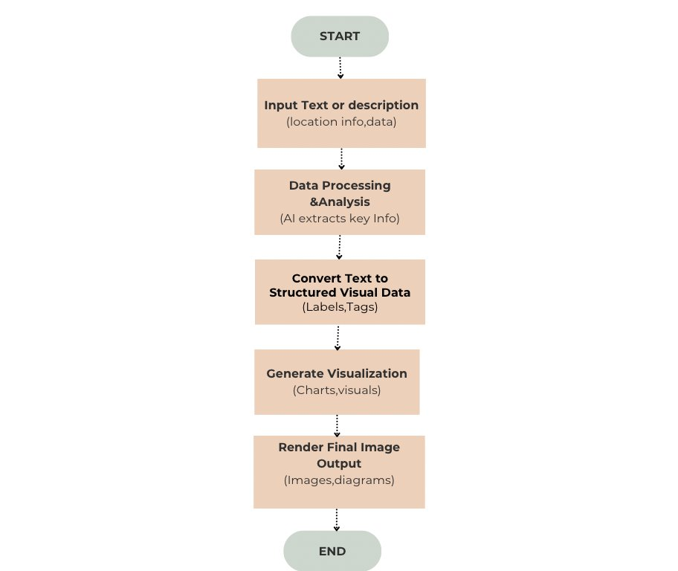

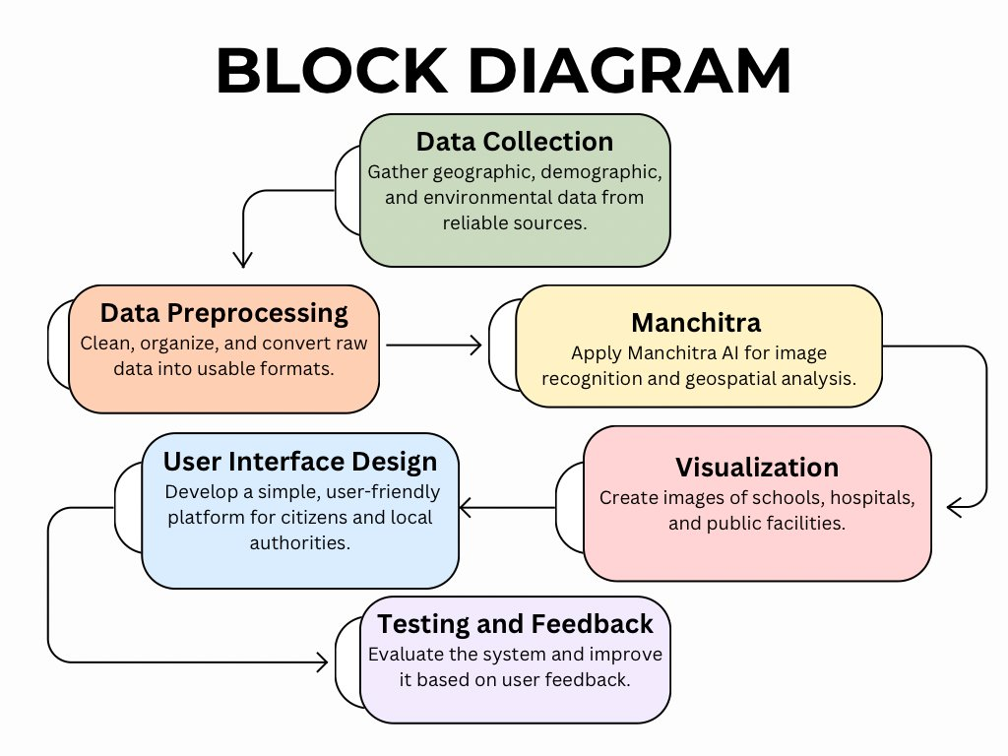
Implementation / Modules

- Data Collection: Gathered basic community information such as landmarks, facilities, and routes.
- Data Processing: Cleaned and organized the collected data into digital format.
- Map Creation: Used mapping and AI tools to generate visual maps of the community.
- Testing: Reviewed and corrected the maps for accuracy and clarity.
- Deployment: Shared the final visual maps with the community through posters and digital media

Results / Outputs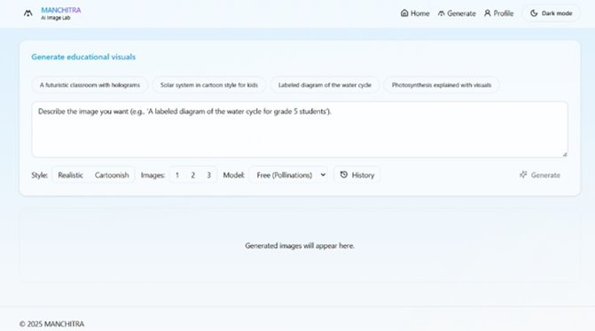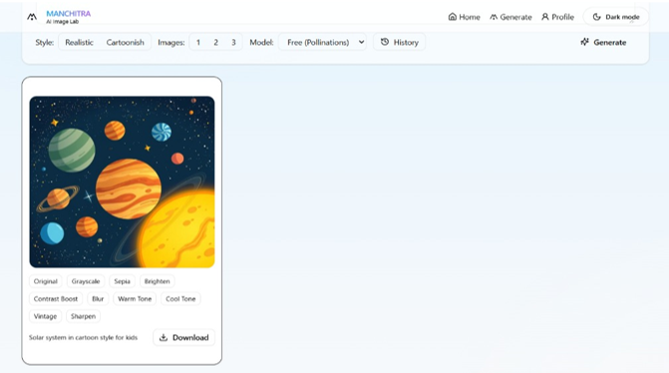

Impact Assessment

Simplifies Creation​
- ​Easy generation of posters, educational visuals, and cultural illustrations.​

Accessible Design​

- Digital design becomes available to underserved or non-technical users.​

Promotes Identity​

- Fosters regional identity and visual storytelling.​

Facilitates Communication​

- Faster, cost-effective communication for NGOs, educators, and local bodies.​

Inspires Creativity​

- Encourages self-expression among students and community members.

Challenges Faced

- Collecting correct and updated community data.​
- Combining different types of data into one system.​
- Fixing errors and missing information in the data.​
- Keeping user data safe and private.​
- Creating a simple and easy-to-use design for everyone.​
- Handling limited tools and resources for data processing.​
- Making sure AI supports people’s decisions, not replaces them.​

Conclusion

- The MANCHITRA: AI for Community Visuals project demonstrate show AI and data visualization can empower communities through insight and collaboration. By converting raw data into meaningful visual representations, it enables better understanding, planning, and decision-making. Ultimately, MANCHITRA fosters transparency, inclusivity, and sustainable community development through the power of intelligent technology.​

Future Work

- Enhance AI models for better data analysis and predictions.​
- Add real-time data integration for live community updates.​
- Develop a mobile-friendly version of the platform.​
- Include multi-language and feedback features for inclusivity.​
- Expand data sources to cover health, education, and environment.​
- Deploy on cloud for scalability and wider accessibility.​
​

References

- Google Cloud. AI and Data Visualization Tools. Retrieved from https://cloud.google.com/​
- IBM Research. Artificial Intelligence for Social Good. Retrieved from https://research.ibm.com/​
- World Bank. Community Data for Development and Planning. Retrieved from https://www.worldbank.org/​
- Esri. GIS and Mapping for Community Engagement. Retrieved from https://www.esri.com/​
- UNDP. Leveraging Technology for Sustainable Community Development. Retrieved from https://www.undp.org/​
- Kaggle. Community Data Visualization Projects. Retrieved from https://www.kaggle.com/​

​
Font Guidelines for the document
Content
Heading- Times New Roman 16 Bold ALL CAPITAL LETTERS
Sub-headings - Times New Roman 14 Bold
Body Text - Times New Roman 12 Line Spacing 1
Tables
List of Tables
Table No. | Title | Page No.
Table x.x
- Font: Times New Roman
- Size: 12 pt
- Table Heading: Bold (centered)
- Column Text: Regular (left-aligned)
- Line Spacing: 1.15

Figures
List of Figures
Figure No. | Title | Page No.
Figure x.x

Font Guidelines:
- Font: Times New Roman
- Size: 12 pt
- Figure Heading: Bold
- Figure Numbers: Sequential (chapter-based, e.g., Figure 2.1 for Chapter 2)

Reference Style
[1] Author(s), “Title,” Journal/Conference, vol., no., pp., year. DOI/URL

